RE-INSTALLATION OF OUTLOOK EXPRESS

1. Click on your start button.
2. Go to control panel

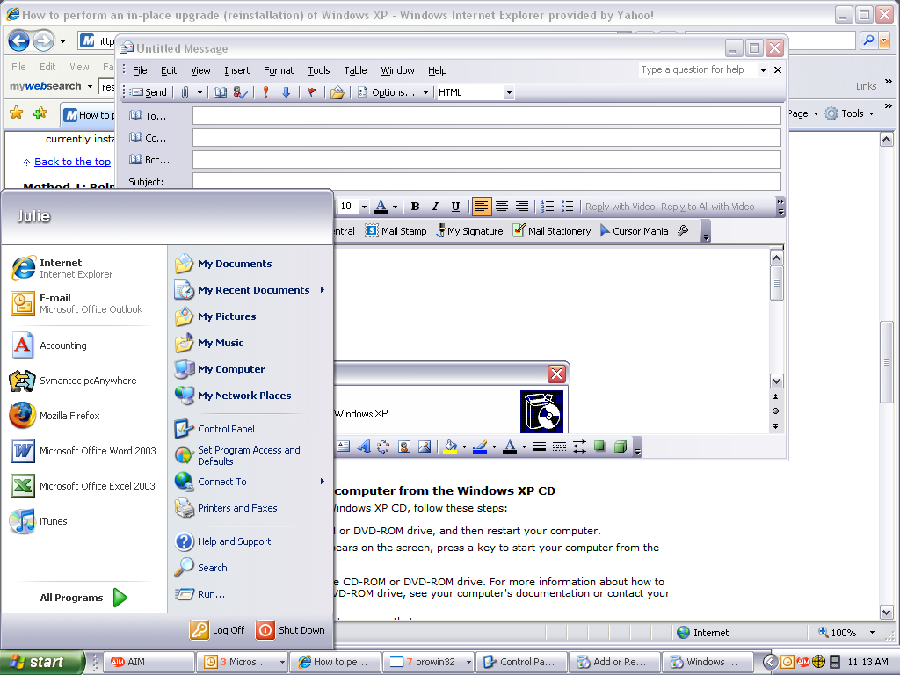

- Click on Add or Remove Programs

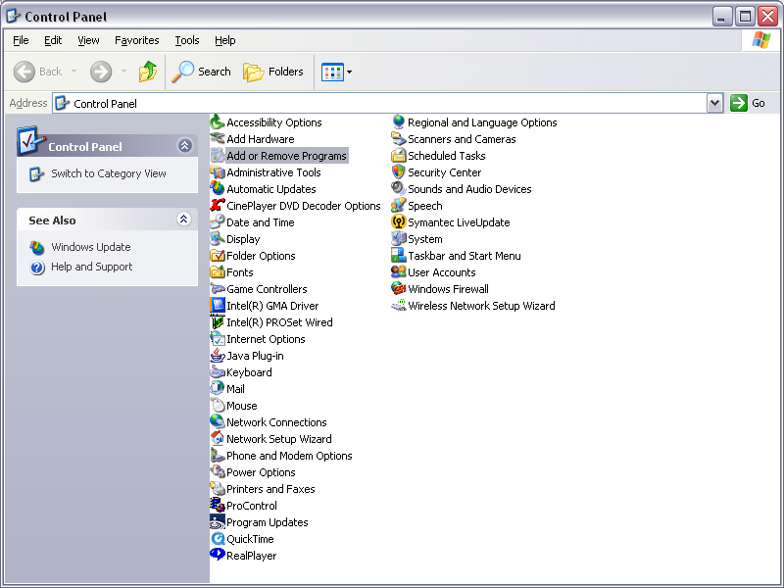

4. Click on Outlook Express if it is unchecked and then click next and follow instructions.

If it is already checked, then uncheck it which should uninstall it.
Then go back in and check the box to re-install it.
If this still doesn’t work, then you will need to call Dell at 1-866-294-6372 and they will walk you through repairing and restoring Express.
They may charge you for this service.

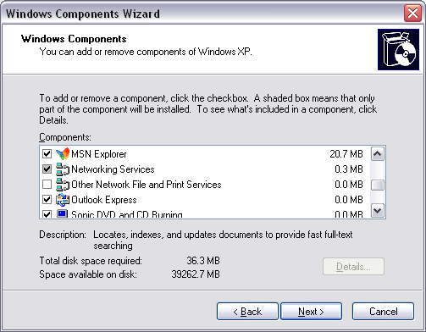

Quatro-Pro is part of Word Perfect productivity pack. This CD WAS sent with the computer.
Go to your start button and go into programs. It would be listed under Word Perfect.
If you don’t see Word Perfect, then I would look to see you can find the CD.
You should have 5 copies, as each computer was sent with one.
I would re-install WordPerfect to get back this program.
If you can’t find it anywhere, I think I have a copy of it here.
Let me know.
___________________
Julie Hentz
Advanced Software
215-369-7800
julie@advantzware.com

